Alejandra Celedon F.

Architectural Association

**Bresciani, Valdés, Castillo, Huidobro.**

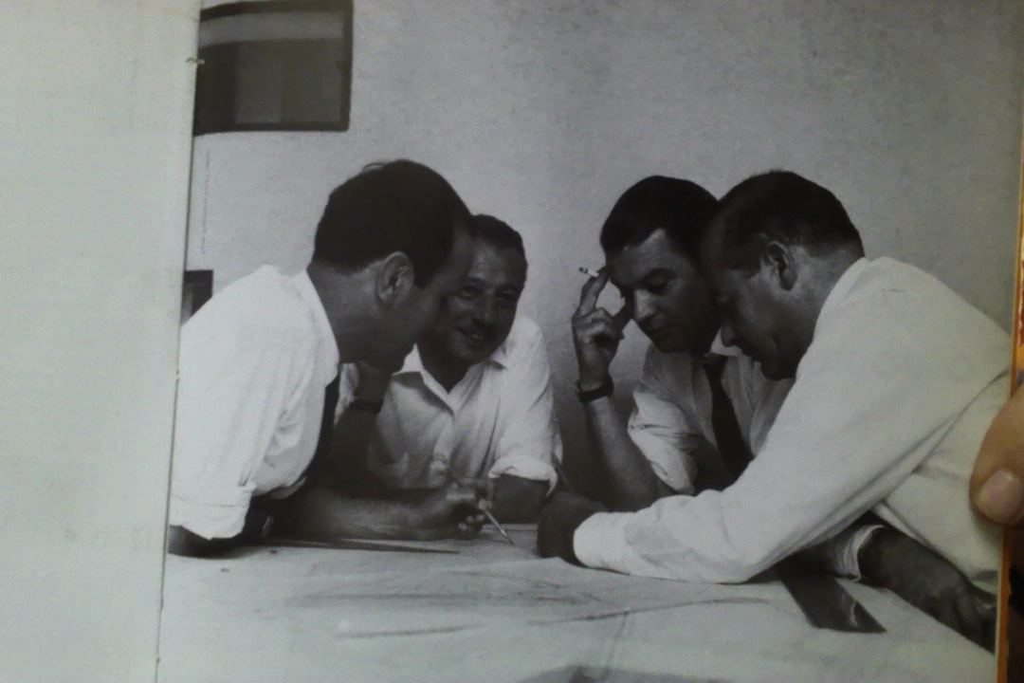

Figure 1: BVCH.

http://www.edicionesarq.cl/2006/bresciani-valdes-castillo-huidobro/

The architectural practice composed by the architects Carlos Bresciani, Hector Valdés, Fernando Castillo y Carlos Huidobro (BVCH) dominated the national scene in the fifties and sixties. The initial group gathered in 1942, originally composed by Valdés, Castillo and Huidobro (VCH), in 1953 joined Bresciani. Their individual careers, spanning well into the nineties, are also extremely significant. Once the modern ideals were more absorbed in the country, the firm managed to put into practice certain principles and modes of production which represents a different architectonic attitude to that of the first half of the century. While the Chilean modernism of early twentieth century was mainly concerned about the construction of public monumental buildings, this second half opens a second trend of development. Along with the building of institutions, central to Chile’s modernity was the construction of social housing. Socially engaged, BVCH architectural practice had a central role in this thread.

They are the authors of the ‘Unidad Vecinal Diego Portales’ (1954-1968), the ‘Torres de Tajamar’ (inaugurated in 1967 and designed with the architect Luis Prieto Vial), and the ‘Remodelación San Borja’ (CORMU[1] 1968-73). The three are exemplary projects of social collective housing in Santiago. The ‘Villa Portales,’ as became known, was a thirty-one hectares development of ninety blocks and almost 2,000 dwelling units and communitarian services in Quinta Normal. The ‘Torres de Tajamar’ was a high-density project of about four hundred dwelling apartments distributed in three towers in less than one hectare. In a privileged location in the riverbed of the Mapocho river in Providencia, the project represented a challenge of competitiveness with real state developments. In turn, ‘Remodelación San Borja’ was a housing complex of twenty-one high-rise towers, one of the most important projects of urban regeneration built in Chile and Latin America.

The practice also designed educational buildings, such as the campuses in Santiago and Punta Arenas for the ‘Universidad Técnica del Estado,’ and single-family houses such as the ‘Santos’ house (1958-61), the ‘Santiago Mingo’ (1955) house, the ‘Orlando Mingo’ house (1957) and the ‘Ravera’ (1953) house, among many others. The prolific firm operated as well as a place of formation of young professionals. More than seventy architects collaborated for the practice along the years, many of them becoming outstanding architects during the 70s.[2] The team managed to interpret social and technological processes of modernisation of the country, using the architectural project as a platform, not any project, but mainly through collective housing proposals. The planning of the house became the place for innovation and experimentation, and to set forth ideas regarding the urban, engaging in these terms with an international disciplinary desire of social and urban reform.

As individuals, each managed to be engaged in the political and academic realms as much as in the practical one, balancing their public and private participation. Valdés and Castillo became influential teachers at the Catholic University in Santiago. Between 1971 and 1973 Valdés was president of the School of National Architects in an extremely politicized environment, when he created the ‘CA Magazine,’ influencing the architectural and political debates. Castillo became Director of the entire university (1967-1973), becoming also professor at Cambridge University and the Central University of Venezuela. He assumed as Mayor of La Reina in 1964, as Intendant of Santiago in 1994, and again as Mayor of La Reina between 1966-2000. Bresciani was Dean of the Faculty of Architecture (1952-1969) in the Catholic University at Valparaiso. Three of his four partners were awarded with the Architectural National Award.

**List of main works**

1942 Echeverría Building

1946 Castillo House.

1953-54 Holanda Building

Ravera House

1954-55 Housing Caja Previsión del Estado

1955-56 Housing Chinchorro

Casa Mingo

1956-57 Housing Estadio

1954-1964 Unidad Vecinal Diego Portales

1958-59 Casa Santos  
1960 UN Competition Entry

1960-61 Games Casino, Arica

Honsa Hostel

Social Security Offices

1961-62 Brasilia Villa

Echeverría House

1962-66 Torres de Tajamar

1964-72 CAP Casino and Offices

1967-70 Remodelación San Borja

**References and further reading**

1. Braun M., Ricardo. Bresciani (1962). Valdés - Castillo - Huidobro. Instituto de Arte Americano e Investigaciones Estéticas, Buenos Aires.

2. Eliash, H. and Moreno, M. (1985) Arquitectura moderna en Chile 1930 – 1960, testimonio y

reflexiones, Cuadernos Luxalón, Santiago.

3. Perez Oyarzun, F. (2006). Bresciani, Valdés, Castillo, Huidobro. Ediciones ARQ, Santiago.

4. Weibel, H. (2008) Phd Thesis: Vivienda Moderna En Chile 1945 -1965 Bresciani-Valdés-Castillo-HuidobroUniversitat Politécnica De Catalunya. Barcelona.

5. Archive: Fondo Documental Bresciani - Valdés - Castillo – Huidobro, part of the Centre of Information and Documentation Sergio Larrain Garcia-Moreno. Drawings and images between 1945-73.

**Visual Material**

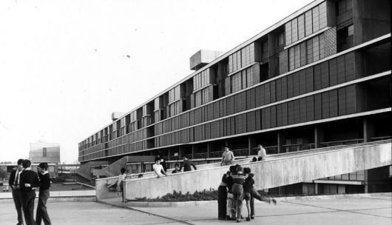

Figure 2: Villa Portales. Cortesy of Casiopea In:

http://www.plataformaarquitectura.cl/2011/04/19/clasicos-de-arquitectura-unidad-vecinal-portales-b-v-c-h/

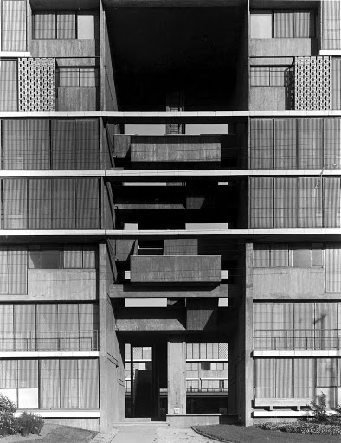

Figure 3: Villa Portales. Cortesy of Casiopea In:

http://www.plataformaarquitectura.cl/2011/04/19/clasicos-de-arquitectura-unidad-vecinal-portales-b-v-c-h/

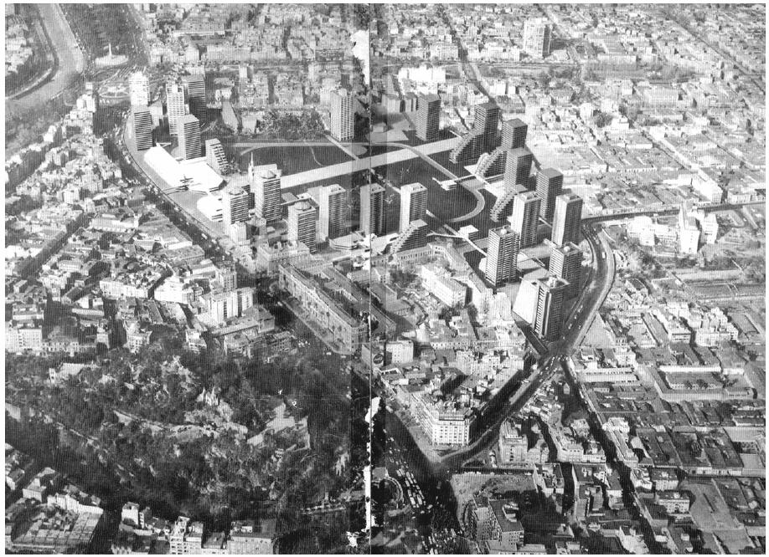

Figure 4: Remodelacion San Borja.

http://www.flickr.com/photos/28047774@N04/4555434259/sizes/o/in/photostream/

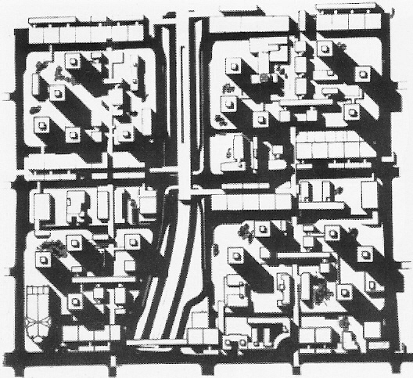

Figure 5: Remodelación San Borja. Original Plan. AUCA Nº24-25, 1973, pp. 23-34.

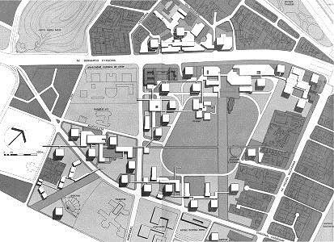

Figure 6: Remodelación San Borja. Original Plan. CA Nº46, Santiago, December 1986, pp. 31-32.

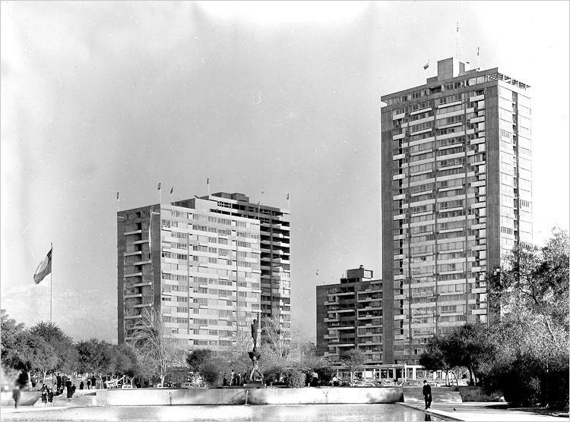

Figure 7: Torres de Tajamar. Cortesía de EAD/PUCV. In:

http://www.plataformaarquitectura.cl/2011/12/20/clasicos-de-arquitectura-torres-de-tajamar-luis-prieto-vial-b-v-c-h/gfrc0016/

1. Urban Improvement Corporation.
2. Pérez Oyarzun, F. (2006). Bresciani, Valdés, Castillo, Huidobro. Ediciones ARQ, Santiago.